

**<<Online-Shop>>**

**Software Requirement Specification**

– Hanoi, August 2022 –

Record of changeS

|  |  |  |  |
| --- | --- | --- | --- |
| Date | A* M, D | In charge | Change Description |
| 13/Apr | A | KienNT | Thêm mô tả chức năng Setting Details (II.1.a) |
| 2/2 | A | Linhtq | Function Requirement(II) |
| 15/2 | A | Linhtq | Thêm ERD(I.3) |
| 19/2 | M | Linhtq | Update context diagram |
| 20/2 | A | Linhtq | Thêm screen flow(I.2.a) |
| 20/2 | A | Linhtq | Theem screen Detail(I.2.b) |
| 21/2 | M | Thanhdq | Update context diagram |
| 27/2 | M | Linhtq | Update Screen Flow |
| 28/2 | M | Thanhdq | Update context diagram |
| 28/2 | A | Thanhdq | Add Entities Description |
|  |  |  |  |

*A - Added

*M - Modified

*D - Deleted

**Table of Contents**

I. Overview 5

1. Introduction 5

2. System Functions 6

3. Entity Relationship Diagram 8

II. Functional Requirements 10

1. Authenticate & Authorise 10

a. Login 10

b. Logout 10

c. Sign Up 11

c. Forgot password 11

2. Paying and Contacting 12

a. Checkout 12

b. Contact 13

3. Manage shopping 13

a. Shopping cart 13

# I. Overview

## 1. Introduction

Sell phone website can replace the current manual and help users buy easier instead of going showroom. The system is expected to be developed after several releases and updates. Besides, the website will link with phone brands to release the latest products.

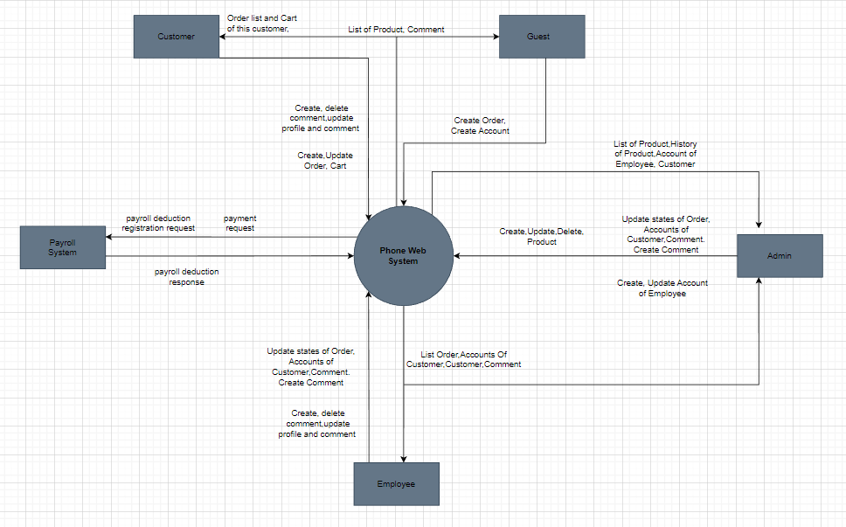

## 2. System Functions

#### a. Screen Flow

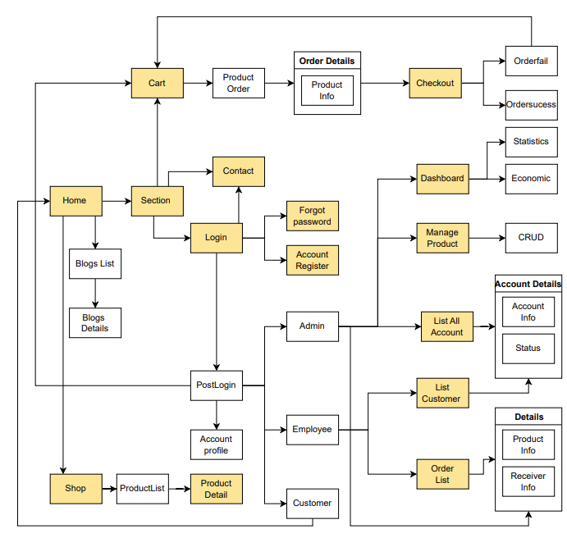

#### b. Screen Details

|  |  |  |  |
| --- | --- | --- | --- |
| **#** | **Feature** | **Screen** | **Description** |
| 1 | Show Product | Shop | Show all products. |
| 2 | Storage Product | Cart | Store the product which user add in order. |
| 3 | User authentication | Login | User can sign in by their account. |
| 4 | User authentication | Forgot password | User can change password when they don’t remember the password. |
| 5 | User authentication | Register | Users create an account. |
| 6 | Contact | Contact | User can send feedback to help improving quality of service. |
| 7 | Payment | Checkout | User can complete order in checkout screen by using credit card, E-wallet or Cash, v.v. |
| 8 | Show Infor | Product Detail | Show the information of the product. |
| 9 | Show Infor | Account Profile | Show the information of the account and they can UR the information. |
| 10 | Order Product | Order Detail | User can CRUD the product in order |
| 11 | Admin | List All Account | Admin can CRUD account status (exam: ban account). |
| 12 | Admin | Dashboard | Admin can see the view order statistics and economic on that time. |
| 13 | Employee | List Customers | Employee can view all Customer mail |
| 14 | Employee | Order List | Employee can CRUD order. |

#### c. User Authorization

|  |  |  |  |  |
| --- | --- | --- | --- | --- |
| **Screen** | **Guest** | **Customer** | **Employee** | **Admin** |
| Home | X | X | X | X |
| Sign In |  | X | X | X |
| Sign Up | X | X | X |  |
| Checkout | X | X | X |  |
| Shopping cart | X | X | X |  |
| Contact | X | X |  |  |
| Product Detail | X | X | X | X |
| Forgot password |  | X | X | X |
| Account Profile | X | X | X |  |
| Order Detail | X | X | X |  |
| List All Account |  |  |  | X |
| Dashboard |  |  |  | X |
| List Customers |  |  | X |  |
| Order List |  |  | X | X |

In which:

* Guest: User who does not have the account
* Customer: User have account
* Employee: Who can manage the products store
* Admin: The owner

#### d. Non-Screen Functions

|  |  |  |  |
| --- | --- | --- | --- |
| **#** | **Feature** | **System Function** | **Description** |
| 1 | **External Interfaces** | **User interface** | -UI-1: The GUI is suitable for display on the PC and laptop.  -UI-2: The layout of the screen is streamlined, easy to  operate, and implement for the user.  -UI-3: For the creator screen, the system must show the confirmation modal (Y / N) for operations add, edit, delete, clone survey.  -UI-4: Use icons to provide visual insights to users.  -UI-5: Encourage vertical scrolling, minimize horizontal scrolling.  -UI-6: All error messages must provide troubleshooting instructions to the user.  -UI-7: Important commands and messages are displayed as buttons and labels with distinct background colors.  -UI-8: For student screen, the system must show confirmation modal (Y / N) for survey submission activity. |
| 2 | … |  |  |

## 3. Entity Relationship Diagram

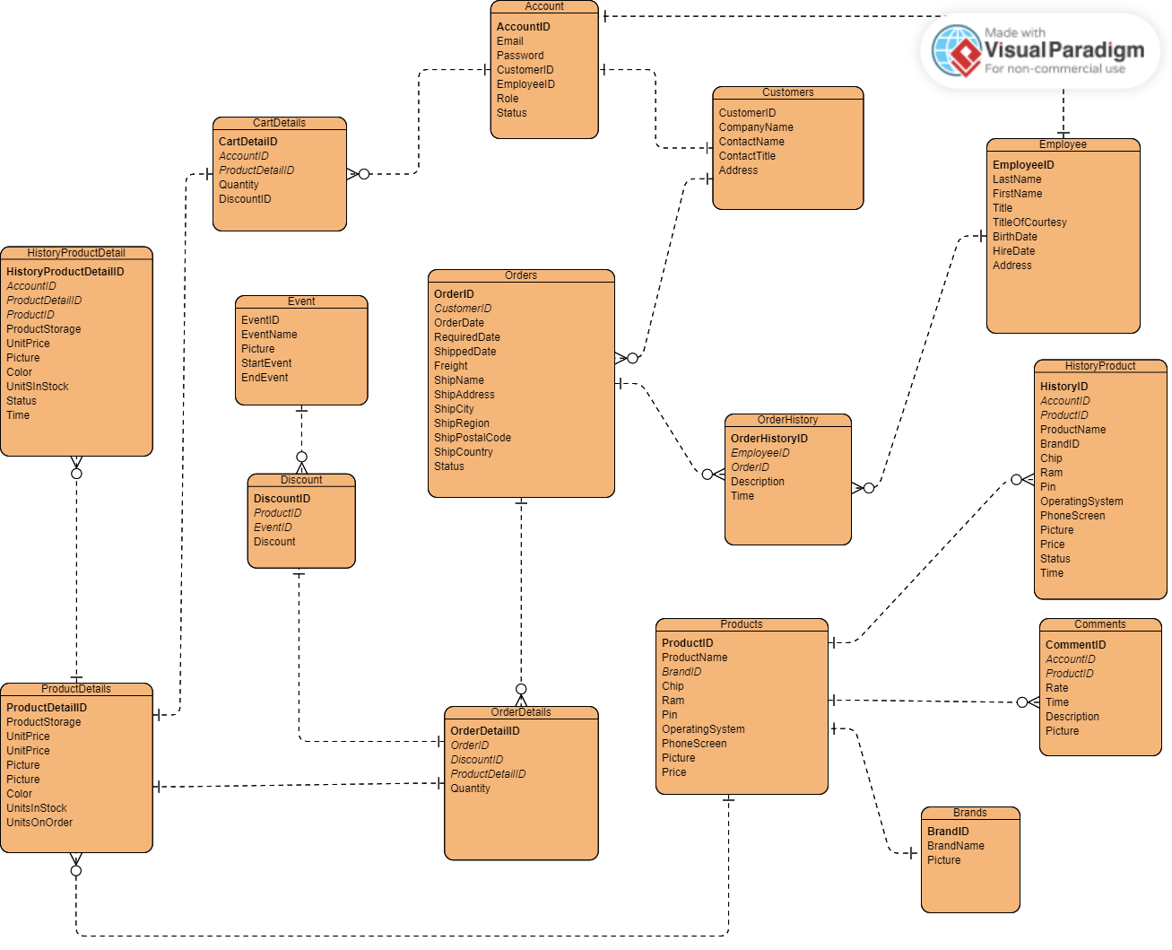

**Entities Description**

|  |  |  |
| --- | --- | --- |
| **#** | **Entity** | **Description** |
| 1 | Accounts | Accounts (Entity): The account of someone when accessing an online shopping website.  AccountID: Used to identify the account record.  Email: The account of the person who owns the account.  Password: The password of the person who owns the account.  CustomerID: ID of customer in Customers table.  EmployeeID: ID of employee in Employees table.  Role: Used to determine the user's function in the online shopping website (0 Admin, 1 Employee, 2 Customer).  Status: The status of the account (1: Active,2: Banned). |
| 2 | Customers | Customers (Entity): Customers who own an account can sign in to the store's website.  CustomerID: Used to identify the  customer record in the Customers table.  CompanyName: The company name of the customer. ContactName: The name of the customer.  ContactTitle: The position of the customer. Address: The address of the customer. |
| 3 | Employees |  |
| 4 | Comments | Comments (Entity): Customers' comments on the products available in the store.  CommentID: Used to identify the comment record in the Comments table.  ProductID: ID of the product that the customer comments on in the Products table.  AccountID: ID of the account that comments in the Accounts table.  Status: The status of the comment (1: Active, 2: Delete).  Rate: The customer's rating for this product, each account can rate a product only once.  Time: The time the user posted this comment.  Description: The user's comment on the product.  Picture: The picture that the user posts. |
| 5 | Products | Products (Entity): Products sold on the online shopping website  ProductID: Used to identify the product record in the Products table  ProductName: The name of the product  BrandID: The ID of the product's brand  Chip: The name of the chip in the product  Pin: The type of battery in the product  OperatingSystem: The operating system of the product  PhoneScreen: The specifications of the product's screen  Picture: The picture describing the product  Price: The product's price (Take the lowest product price in the ProductDetails table). |
| 6 | ProductDetails | ProductDetails (Entity): Detailed information about the product  ProductDetailsID: Used to identify the product detail record in the ProductDetails table  ProductID: The ID of the product that has this ProductDetail  ProductStorage: The capacity of the product  UnitPrice: The price of the product  Picture: The illustration image of the product with the properties in this table  Color: The color of the product  UnitsInStock: The number of items in stock  UnitsOnOrder: The number of items on order. |
| 7 | HistoryProducts | HistoryProducts (Entity): The history of updating, deleting, and creating a product  HistoryID: Used to identify the HistoryProduct record in the HistoryProducts table  AccountID: The ID of the account that performed this history  ProductID: The ID of the product that was updated, created, or deleted  ProductName: The name of the product  BrandID: The ID of the product's brand  Chip: The name of the chip in the product  Pin: The type of battery in the product  OperatingSystem: The operating system of the product  PhoneScreen: The specifications of the product's screen  Picture: The picture describing the product  Price: The product's price (Take the lowest product price in the ProductDetails table). |
| 8 | HistoryProductDetails | HistoryProductDetails (Entity): History of updates, deletions, and creations of ProductDetail  HistoryProductDetailID: Used to identify the HistoryProductDetail record in the HistoryProductDetailIDs table  AccountID: ID of the account that performed this history  ProductID: ID of the product that has this ProductDetail  ProductStorage: Storage capacity of the product  UnitPrice: Price of the product  Picture: Illustration picture of the product with its attributes  Color: Color of the product  UnitsInStock: Quantity in stock  UnitsOnOrder: Quantity on order. |
| 9 | Events | Events (Entity): The events within a certain time period of the store  EventID: Used to identify the Event record in the Events table  EventName: The name of the event  Picture: The image of the event  StartEvent: The start time of the event  EndEvent: The end time of the event. |
| 10 | Discounts | Discounts (Entity): The discount of a product in the store  DiscountID: Used to identify the Discount record in the Discounts table  ProductID: The ID of the product that has this discount  EventID: The ID of the event of the discount  Discount: The percentage of discount. |
| 11 | Orders | Orders (Entity): The customer's order when purchasing a product  OrderID: Used to identify the Order record in the Orders table  CustomerID: The ID of the customer who placed this order  OrderDate: The time the order was approved  RequiredDate: The time the product is requested to be shipped to the customer  ShippedDate: The actual time the product was shipped to the customer  Freight: The weight of the order  ShipName: The name of the customer who receives the shipment  ShipAddress: The address of the shipment  ShipCity: The shipping company  ShipRegion: The province of the shipment  ShipPostalCode: The shipment code  ShipCountry: The country of the shipment  Status: The status of the order (0: Order Deleted, 1: Approved, 2: Pending Approval) |
| 12 | OrderDetails | OrderDetails (Entity): The details of the order  OrderDetailID: Used to identify the OrderDetail record in the OrderDetails table  OrderID: The ID of the order that owns this OrderDetail  DiscountID: The ID of the Discount of this OrderDetail  ProductDetailID: The ID of the product in this OrderDetail  Quantity: The quantity of the product. |
| 13 | OrderHistories | OrderHistories: The history of changes in the status of an Order  OrderHistoryID: Used to identify the OrderHistory record in the OrderHistories table  EmployeeID: The ID of the employee who changed the status  Description: Approve or disapprove the order  Time: The time when the Order status was changed  OrderID: The ID of the order that was changed. |
| 14 | CartDetails | CartDetails (Entity):  CartDetailID:  DiscountID:  ProductDetailID:  Quantity: |
| 15 | Brands | Brands (Entity): The brand of the products in the shop  BrandID: Used to identify the Brand record in the Brands table  BrandName: The name of the brand  Picture: The logo of the brand. |
|  |  |  |

# II. Functional Requirements

## 1. Authenticate & Authorise

### a. Login

Function Trigger:

* Navigation Path: Login Screen
* Frequency of Use: High

Function Description:

* Actors: All
* Purpose: User login into the system
* Data processing: Data wrapped as a request through a secure connection

Screen Layout:

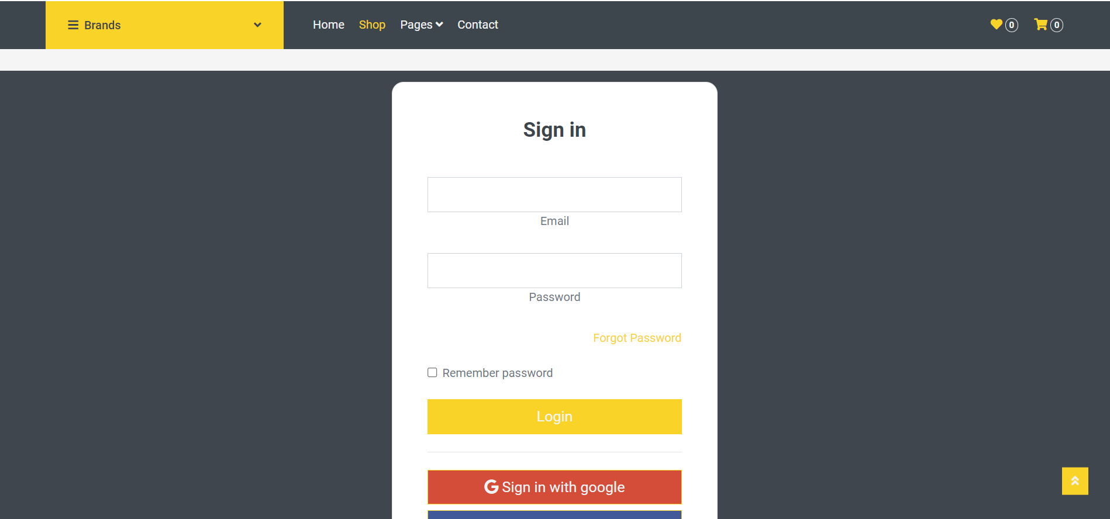

Function details:

* Normal case: User logins successfully
* Abnormal case: Wrong email or password, etc.

### b. Logout

Function Trigger:

* Navigation Path: Click “My Account” icon → click on “SignOut”
* Frequency of Use: High

Function Description:

* Actors: All
* Purpose: User logout to the website
* Data processing: Data wrapped as a request through a secure connection
* 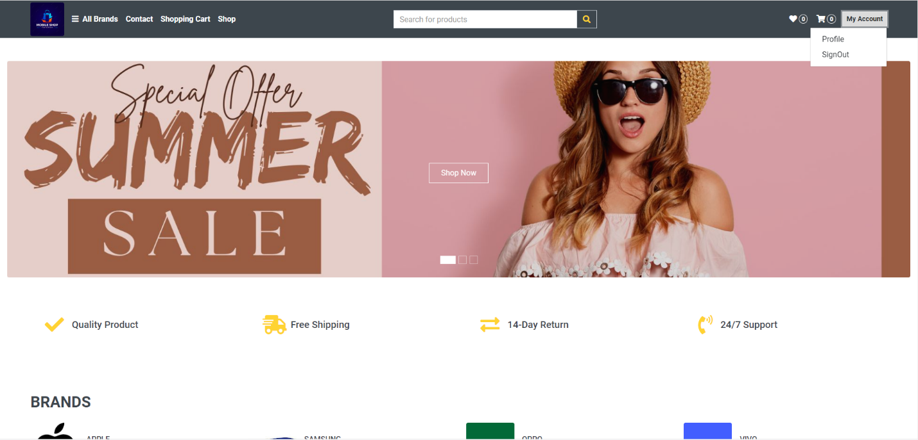Screen Layout:

 Function details:

* Normal case: User logout successfully
* Abnormal case

### c

### Sign Up

Function Trigger:

* Navigation Path: Click “My Account” icon → click on “Sign up”
* Frequency of Use: High

Function Description:

* Actors: User don’t have account or google account
* Purpose: Create user account
* Data processing: Data wrapped as a request through a secure connection
* Screen Layout:

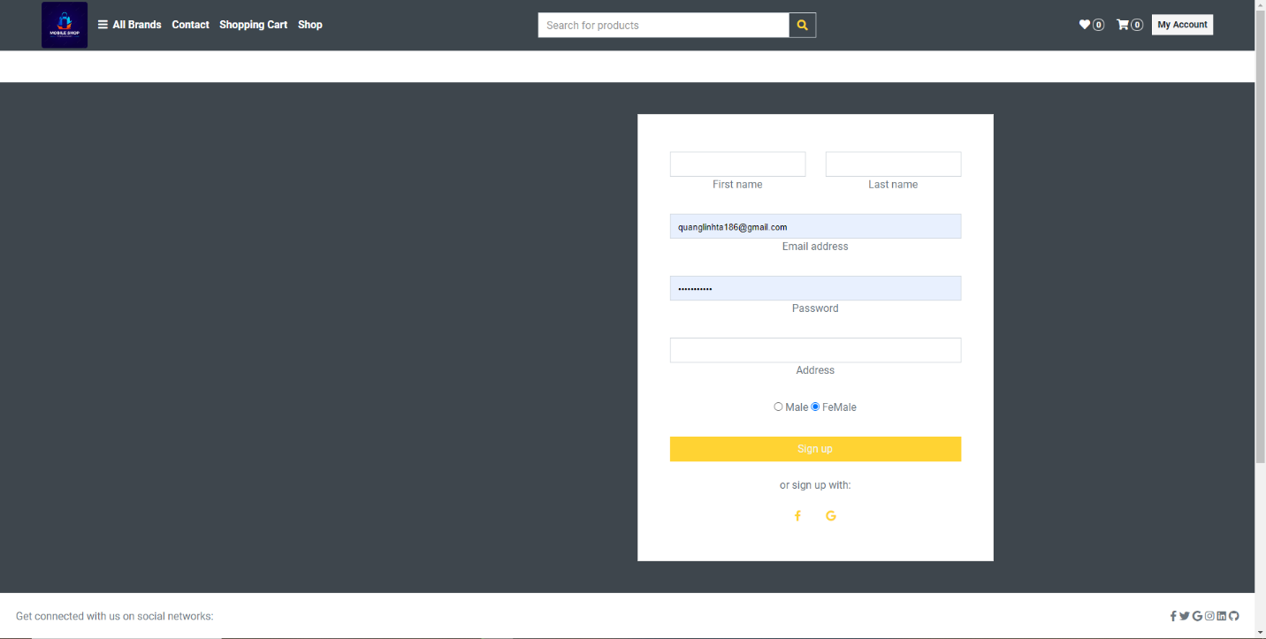

 Function details:

* Normal case: Create account successfully
* Abnormal case: Invalid data, email exist, not fill, …

### d

### Forgot password

Function Trigger:

* Navigation Path: Click “Forgot password” icon
* Frequency of Use: Normal

Function Description:

* Actors: User don’t remember the password
* Purpose: Help user can change password by email address
* Data processing: Data wrapped as a request through a secure connection
* Screen Layout:



 Function details:

* Normal case: Create account successfully
* Abnormal case: Invalid data, email exist, not fill, …

### 2

### Paying and Contacting

### a

### Checkout

Function Trigger:

* Navigation Path: Click “Pages” icon → click on “Checkout”
* Frequency of Use: Normal

Function Description:

* Actors: All
* Purpose: Payment
* Data processing: Data wrapped as a request through a secure connection
* Screen Layout:

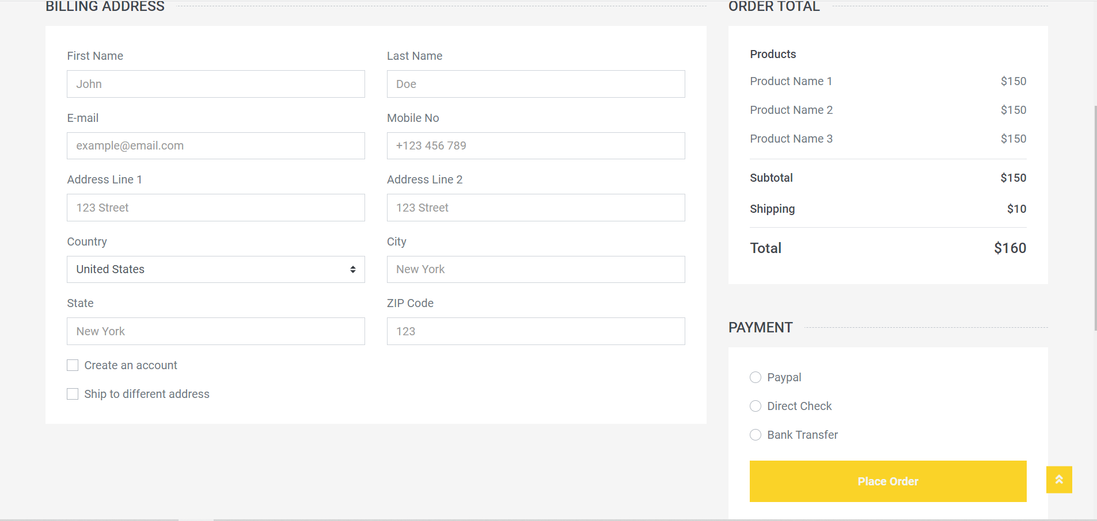

 Function details:

* Normal case: Paying successfully
* Abnormal case: Invalid data, missing checkbox,…

### b

### Contact

Function Trigger:

* Navigation Path: Click “Contact” icon in bar
* Frequency of Use: Normal

Function Description:

* Actors: All
* Purpose: Help user feedback
* Data processing: Data wrapped as a request through a secure connection
* Screen Layout:

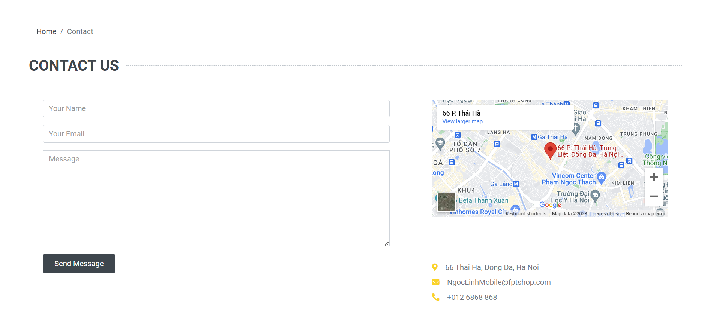

 Function details:

* Normal case: Send message successfully
* Abnormal case: Invalid data, not fill, …

### 3 Manage shopping

### Shopping cart

Function Trigger:

• Navigation Path: Click on "Add to Cart" button for a product

• Frequency of Use: High

Function Description:

• Actors: All users who want to buy products

• Purpose: Allow users to store products they want to purchase

• Data processing: Data stored in the shopping cart should be encrypted and transmitted via a secure connection

• Screen Layout:

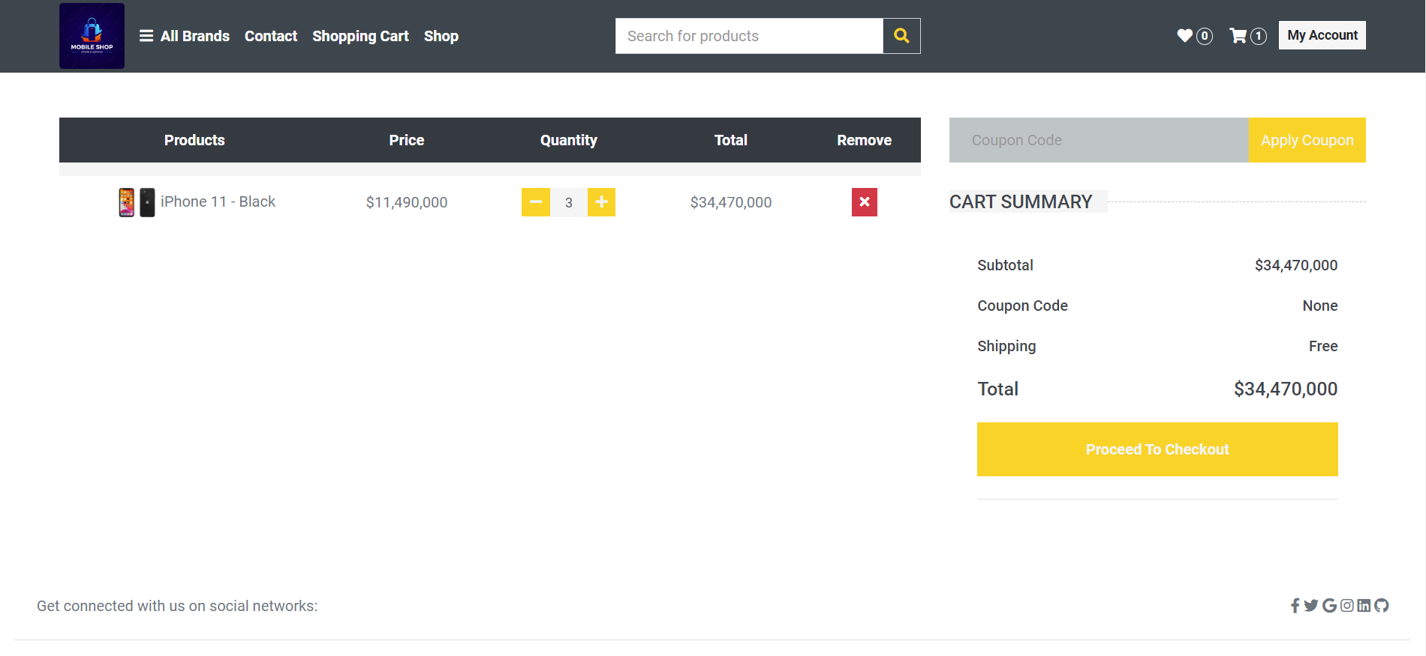

Function Details:

• Normal case:

User adds items to the shopping cart

User can view and modify the contents of the shopping cart

User can proceed to checkout from the shopping cart

• Abnormal case:

If the shopping cart is empty, the user should see a message indicating that the cart is empty

If the user tries to add an out-of-stock or unavailable product, they should see a message indicating that the product is not available

If the user tries to add more items than the available stock, they should see a message indicating that the quantity is not available

If the user tries to remove an item that is not in the cart, they should see a message indicating that the item is not in the cart

### Shopping cart discount

Function Trigger:

• Navigation Path: Enter a valid discount code in the shopping cart and click the "Apply" button

• Frequency of Use: Medium

Function Description:

• Actors: All users who want to apply discounts to their shopping cart

• Purpose: Allow users to apply discounts to their total purchase price

• Data processing: Data retrieved from the database based on the user's discount code and applied to the shopping cart total

• Screen Layout:

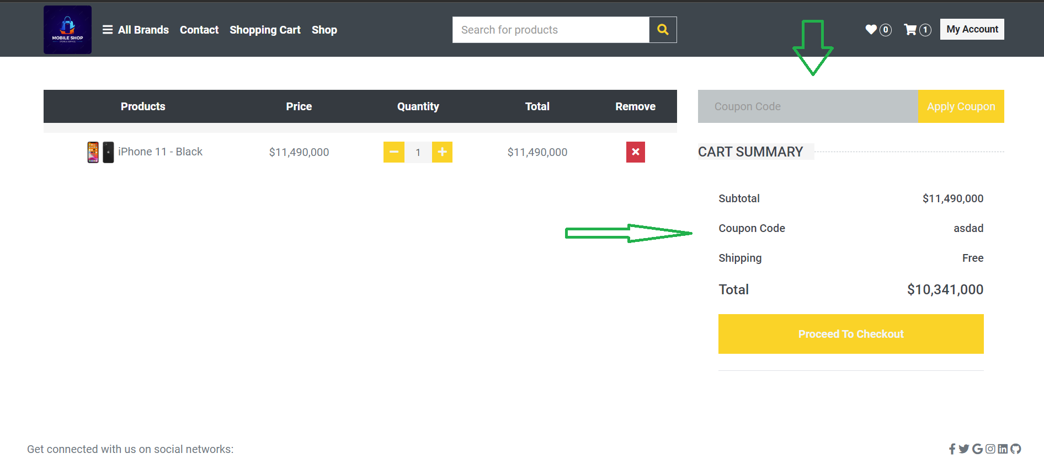

Function Details:

• Normal case:

User enters a valid discount code in the shopping cart and clicks the "Apply" button

The discount is applied to the shopping cart total, and the user can see the updated price

User can proceed to checkout with the discounted price

• Abnormal case:

If the discount code is invalid or expired, the user should see a message indicating that the code is invalid or expired

If the discount code has already been used, the user should see a message indicating that the code has already been used

If there is an error applying the discount, the user should see a message indicating that there was an error applying the discount.

### 4. Detail Product

### View Detail Product

Function Trigger 1:

* Navigation Path: Click “Shop” icon in bar.
* Frequency of Use: High.

Function Description:

* Actors: All.
* Purpose: Help user see all products or list product by filter.
* Data processing: Data wrapped as a request through a secure connection

Screen Layout:

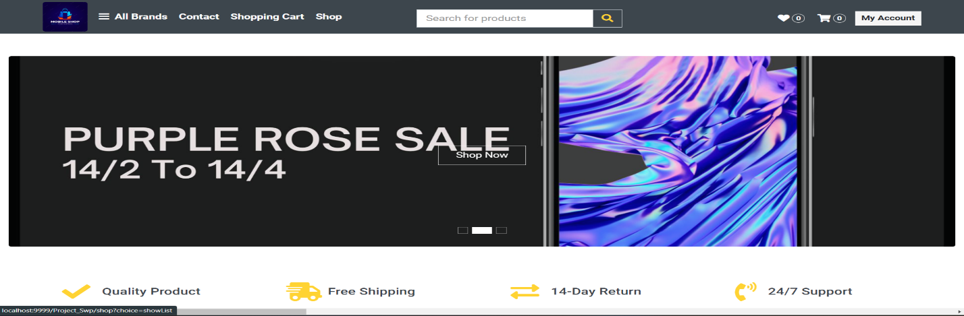

Function details:

* Normal case: View list product that customers want to see
* Abnormal case: Invalid data, the link is broken or leads to a non-existent page (404 error),…

Function Trigger 2:

* Navigation Path: Use the mouse pointer to scroll down to see the list of products on the homepage of the website.
* Frequency of Use: High.

Function Description:

* Actors: All.
* Purpose: Help user see all products or list product by filter.
* Data processing: Data wrapped as a request through a secure connection

Screen Layout:

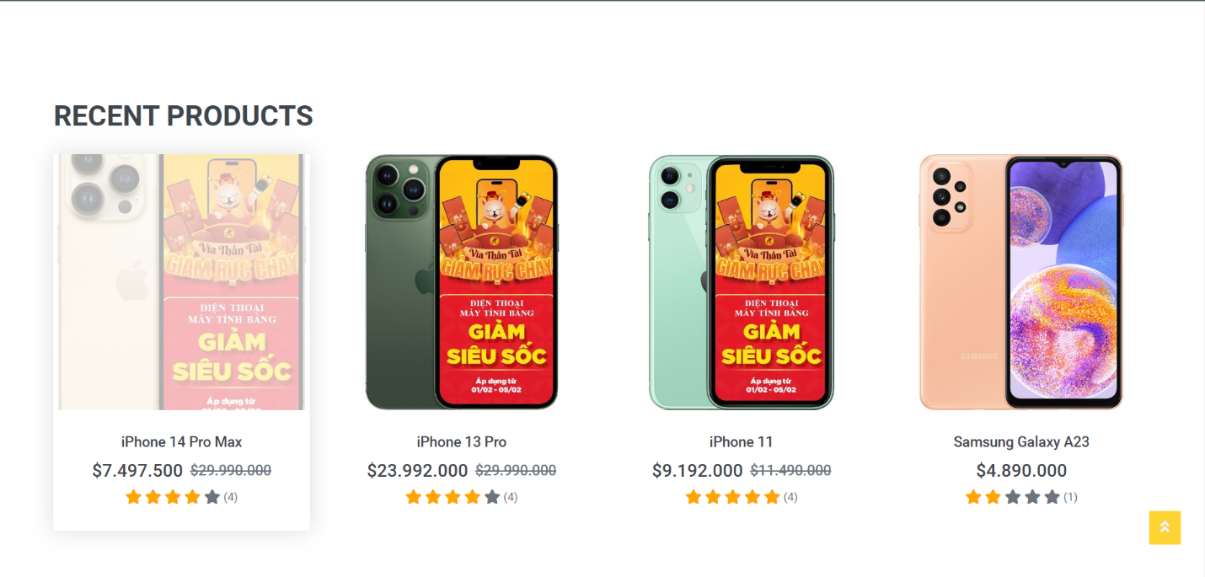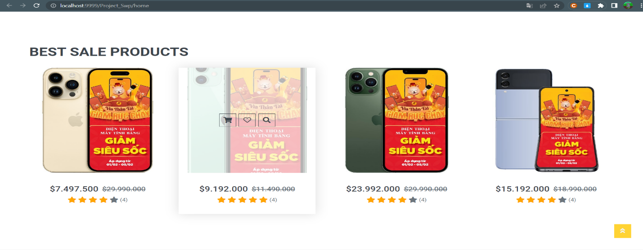

Function details:

* Normal case: View list product that customers want to see
* Abnormal case: Invalid data, the link is broken or leads to a non-existent page (404 error),…

Function Trigger 3:

* Navigation Path: Click on a “Product”.
* Frequency of Use: High.

Function Description:

* Actors: All.
* Purpose: Help user see all information of a product: Name product, Price, Storage, Color,...
* Data processing: Data wrapped as a request through a secure connection

Screen Layout:

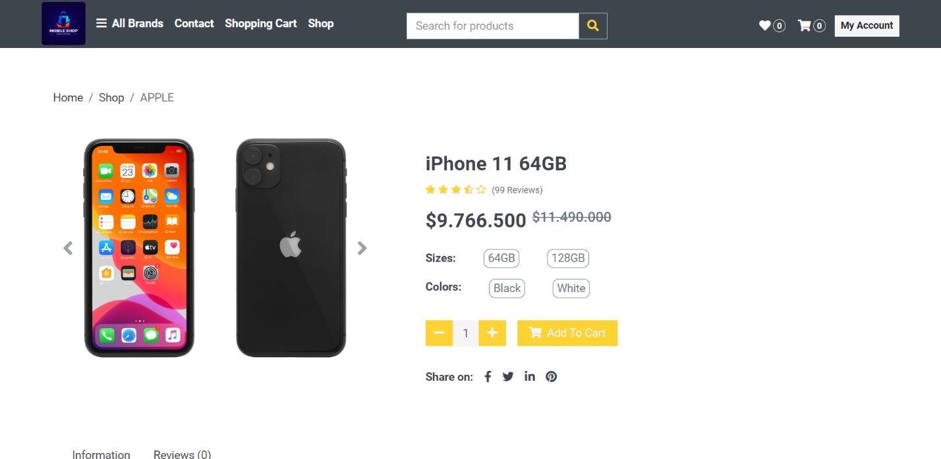

Function details:

* Normal case: The product information is fully displayed, memory filter operations or product color work normally.
* Abnormal case: Invalid data, the link is broken or leads to a non-existent page (404 error), Can't work with filters,…

Function Trigger 4:

* Navigation Path: Click on a “Review”.
* Frequency of Use: High.

Function Description:

* Actors: All.
* Purpose: Allows users to rate, ask questions or request service about the product,...Data processing: Data wrapped as a request through a secure connection

Screen Layout:

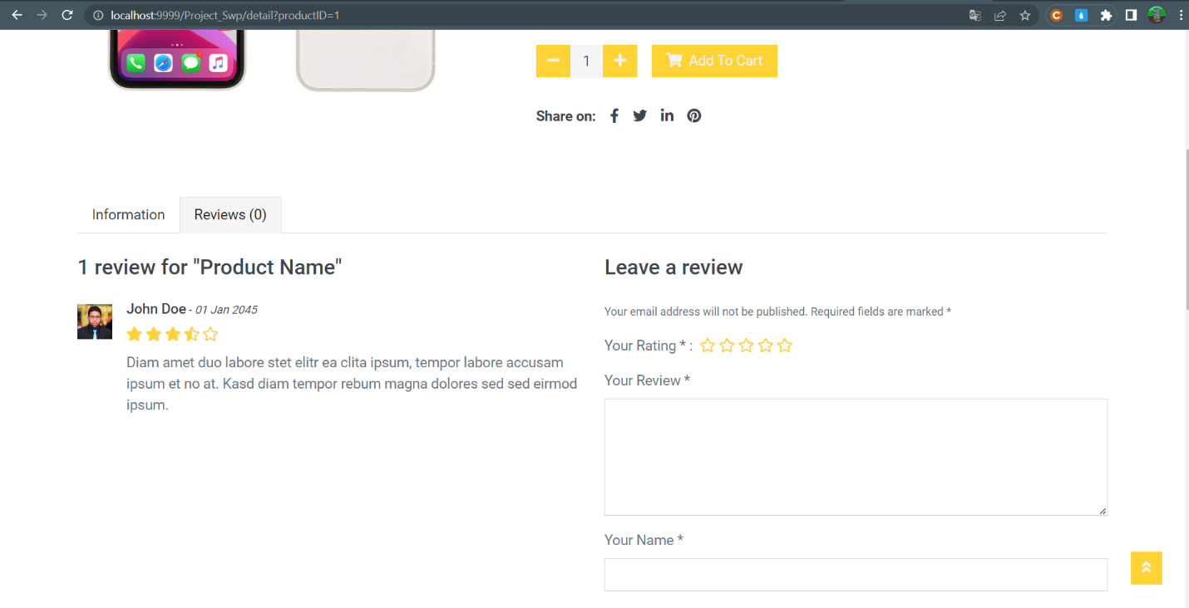

Function details:

* Normal case: Full operation of the functions of the "Review" section: comment, star rating,...Abnormal case
* Abnormal case: Can't work with sections in "Review"

### 5. Show Product

### View Product

Function Trigger:

• Navigation Path: Click on show an then click a product image or name

• Frequency of Use: High

Function Description:

• Actors: All users who want to view product details

• Purpose: Allow users to view detailed information about a product before making a purchase

• Data processing: Data retrieved from the database and displayed on the screen

• Screen Layout:

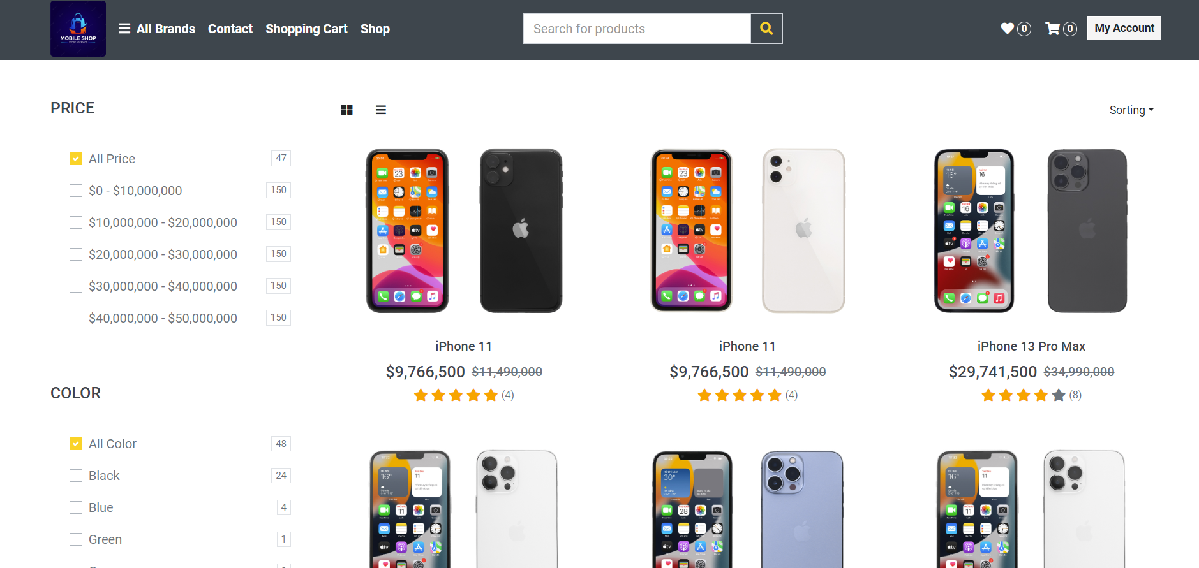

Function Details:

• Normal case:

User clicks on a product image or name to view product details

User sees detailed information about the product, including name, description, price, availability, and product images

User can add the product to the shopping cart from the product details page

• Abnormal case:

If the product details are not available, the user should see a message indicating that the product is not available

If the product image is not available, the user should see a default image placeholder

If the product is out of stock or unavailable, the user should see a message indicating that the product is not available for purchase

If there is an error retrieving the product details, the user should see a message indicating that there was an error retrieving the information.

### Searching Product

Function Trigger:

• Navigation Path: Enter a search query in the search bar and click the search button

• Frequency of Use: High

Function Description:

• Actors: All users who want to search for products by name

• Purpose: Allow users to find products that match their search query

• Data processing: Data retrieved from the database based on the user's search query

• Screen Layout:

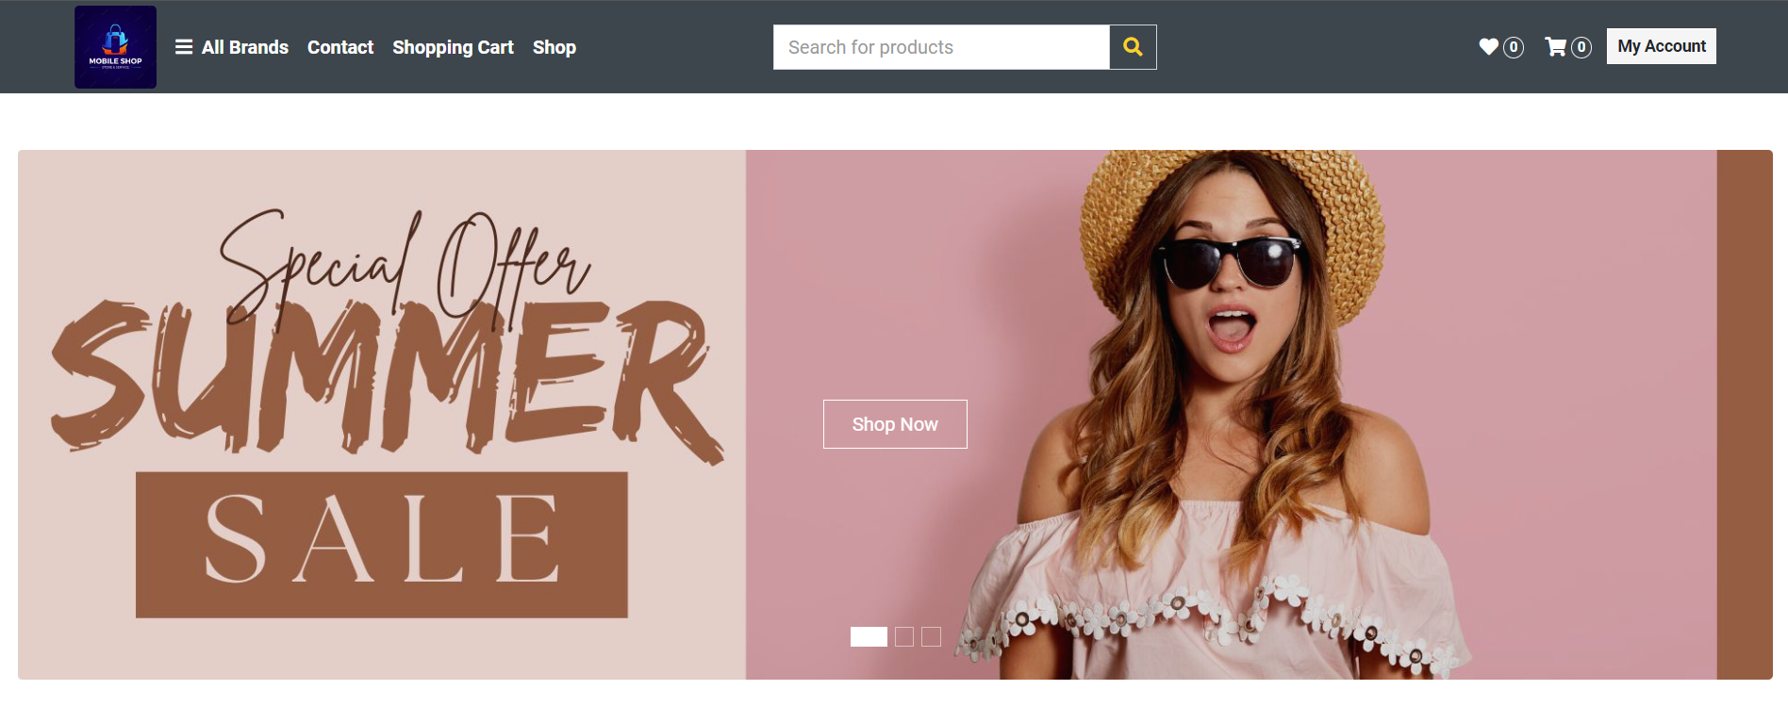

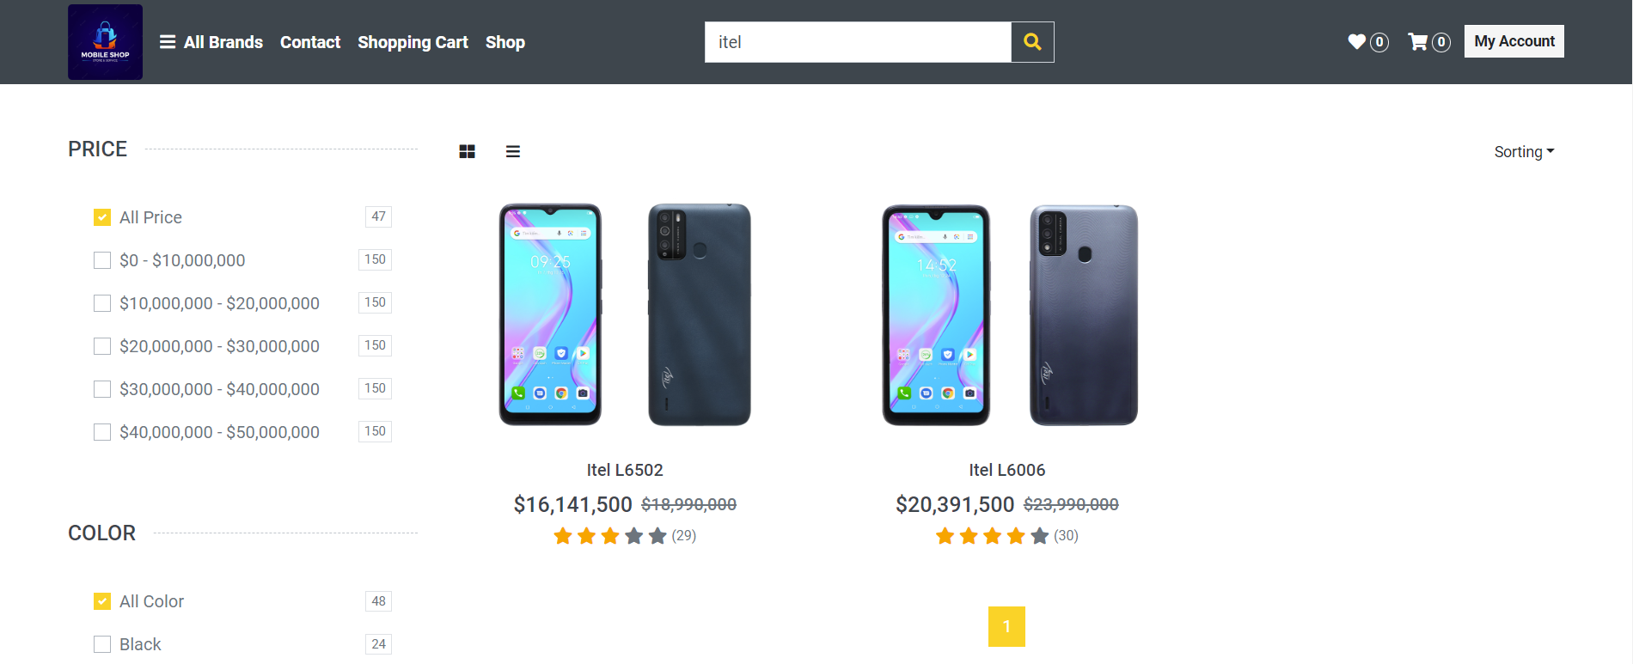

Function Details:

• Normal case:

User enters a search query in the search bar and clicks the search button

Products that match the search query are displayed on the screen

User can click on a product to view detailed information or add it to the shopping cart

• Abnormal case:

If there are no products that match the search query, the user should see a message indicating that there are no products that match their search

If there is an error retrieving the search results, the user should see a message indicating that there was an error retrieving the information.

### Filter Product

Filter Products by Brand, Price, Storage, and Color

Function Trigger:

• Navigation Path: Click on the "Filter" button or dropdown menu

• Frequency of Use: High

Function Description:

• Actors: All users who want to filter products based on specific criteria

• Purpose: Allow users to find products that meet their specific needs and preferences

• Data processing: Data retrieved from the database based on the user's selected criteria

• Screen Layout:

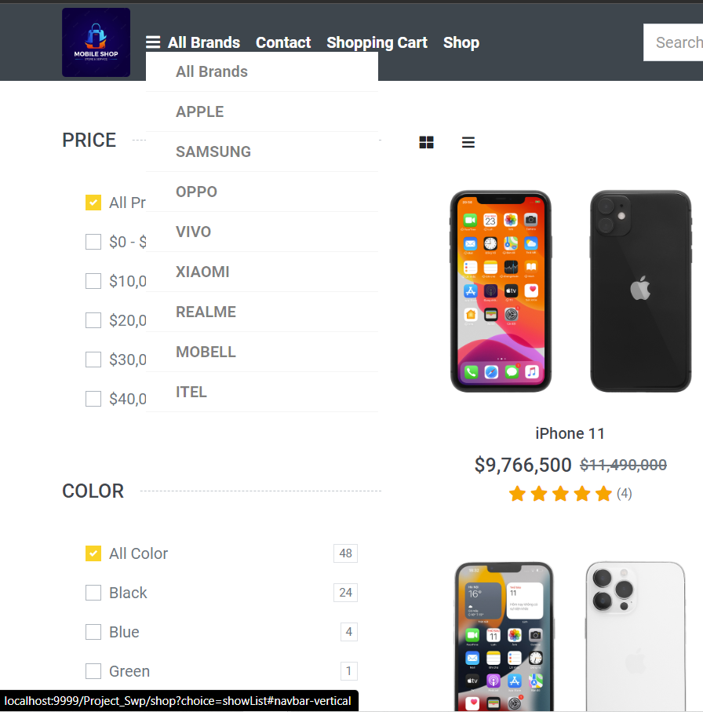

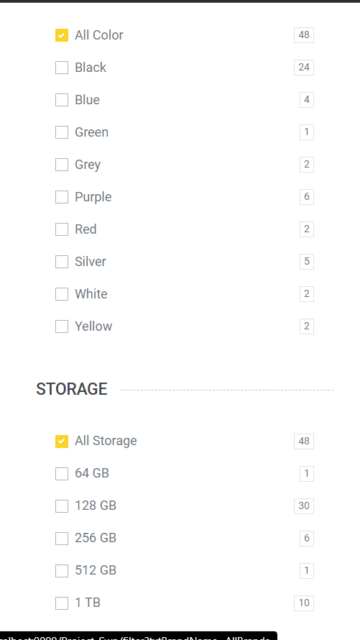

Function Details:

• Normal case:

User clicks on the "Filter" button or dropdown menu to display the filtering options

User selects one or more criteria, such as brand, price range, storage capacity, and color

Products matching the selected criteria are displayed on the screen

User can click on a product to view detailed information or add it to the shopping cart

• Abnormal case:

If there are no products that match the selected criteria, the user should see a message indicating that there are no products that match their search

If there is an error retrieving the filtered products, the user should see a message indicating that there was an error retrieving the information

If the user selects conflicting criteria (e.g. a price range that includes no products), the user should see a message indicating that the criteria are conflicting and cannot be used together